Day-5 Assignment
Q1. List all the main components you find inside a desktop PC after opening the cabinet, and write a short description (1-2 lines) for each.
Ans.
Motherboard: The main printed circuit board that connects all internal components together and allows them to communicate.
Central Processing Unit (CPU): The primary processing chip that executes instructions and handles calculations for the computer.
Graphics Processing Unit (GPU / Video Card): A dedicated hardware component that renders images, video, and 3D graphics for display.
Random Access Memory (RAM): Fast, temporary storage modules that hold data currently in use by the CPU for quick access.
Storage (SSD / HDD): Long-term storage drives used to save the operating system, applications, games, and personal files.
Power Supply Unit (PSU): The component that converts electricity from a wall outlet into the proper voltages needed by the internal hardware.
CPU Cooler: A heatsink and fan (or liquid block) assembly mounted on the processor to dissipate heat and prevent overheating.
Case Fans: Fans mounted to the PC chassis that pull cool air in and expel hot air to maintain a stable internal temperature.

Q2. Take clear photos or draw labeled diagrams of each step as you disassemble a desktop PC, and organize them in a document with captions explaining what you did at each step.
Ans.
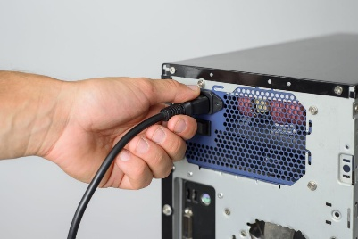
Step 1: Unplug the power
Shut down the computer and disconnect the power cable and all external devices.
Caption: The computer was switched off and disconnected from the power source for safety.
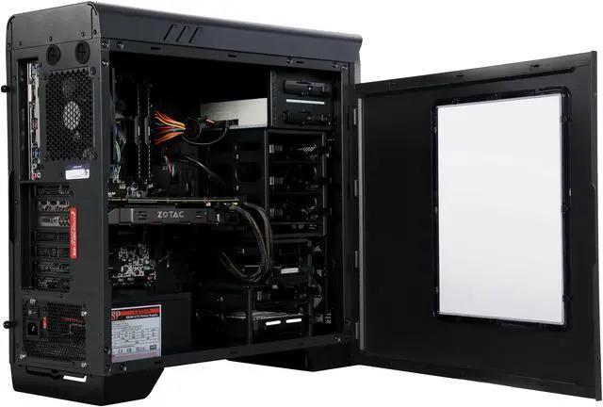
Step 2: Remove the side panel
Unscrew the case panel and carefully slide it off to access the internal components.
Caption: The side panel was removed to expose the motherboard and other hardware.
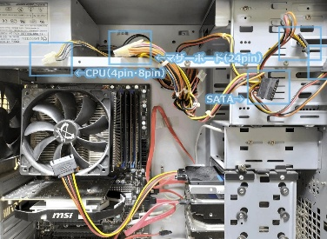
Step 3: Disconnect cables
Carefully disconnect the motherboard power, CPU power, storage data, and other necessary cables.
Caption: Internal cables were disconnected carefully before removing components.
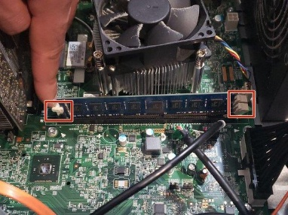
Step 4: Remove RAM
Release the slot clips and lift the RAM module by its edges.
Caption: The RAM module was removed carefully without touching its gold contacts.
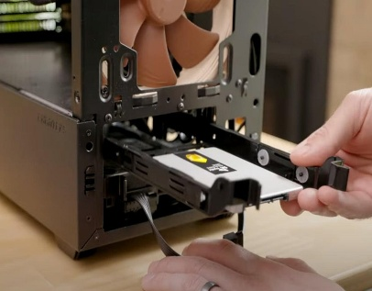
Step 5: Remove HDD/SSD
Disconnect the data and power cables, remove the mounting screws, and take out the storage drive.
Caption: The storage device was removed from its mounting bay.
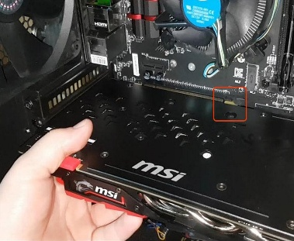
Step 6: Remove the graphics card
Remove the bracket screws, release the PCIe slot latch, and carefully withdraw the GPU.
Caption: The graphics card was removed after disconnecting its power cables.
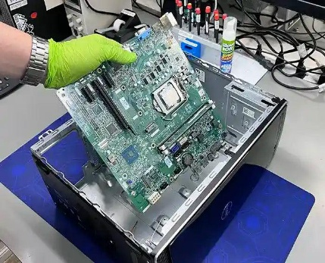
Step 7: Remove the motherboard
Ensure all cables and attached components are disconnected as needed. Unscrew the motherboard from its standoffs and lift it carefully.
Caption: The motherboard was removed from the case after all connections and screws were checked.
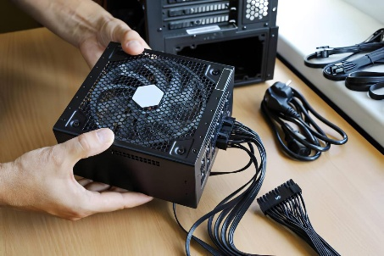
Step 8: Remove the power supply
Unscrew the PSU mounting screws and slide the unit out of the case. Never open the PSU casing.
Caption: The power supply was removed from its mounting position.
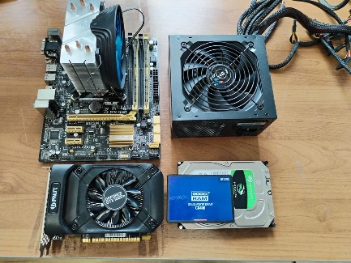
Step 9: Final inspection
Arrange the removed components safely and identify each part.
Caption: All removed components were inspected and identified after disassembly.

Q3. Reassemble the PC you disassembled, documenting each step with a brief explanation of what you connected or installed and why the order matters.
Ans.
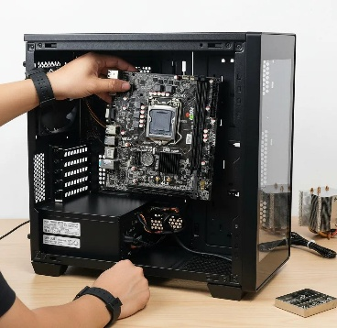
Step 1: Install the motherboard
Place the motherboard onto the correct case standoffs and tighten the screws gently.
Why first? It provides the base for connecting the CPU, RAM, storage, and other components.
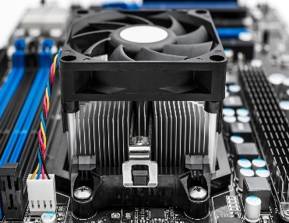
Step 2: Install the CPU cooler (if removed)
Ensure the CPU is correctly seated, apply thermal paste if required, and securely mount the compatible cooler. Connect its fan to the CPU_FAN header.
Why now? The processor needs proper cooling before the computer is powered on.
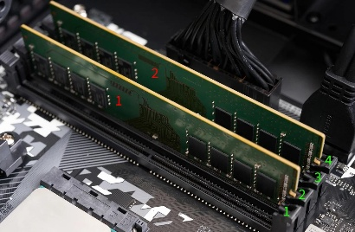
Step 3: Install RAM
Align the notch on each RAM module with the slot and press gently until the retaining clips engage.
Why now? RAM is easier to install while the motherboard is accessible.
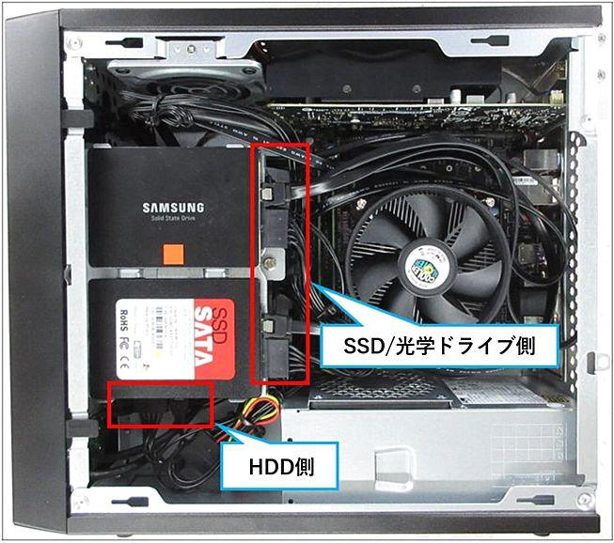
Step 4: Install the HDD/SSD
Secure the drive in its mounting bay and connect the appropriate SATA data and power cables, or reinstall an M.2 SSD in its slot.
Why now? Storage must be installed and connected for the system to access its operating system and files.
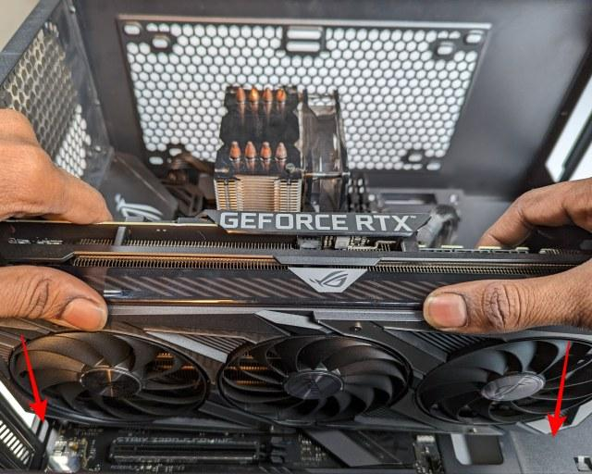
Step 5: Install the GPU
Insert the graphics card into the appropriate PCIe slot, secure its bracket, and connect any required GPU power cables.
Why now? The GPU is easier to fit after other nearby components and cables are positioned.
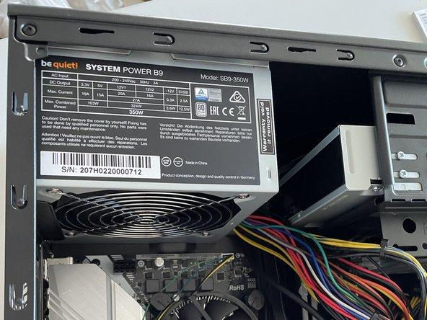
Step 6: Install the power supply
Secure the PSU in its designated compartment and route its cables neatly.
Why now? This makes it easier to route and connect the power cables without obstructing installation.
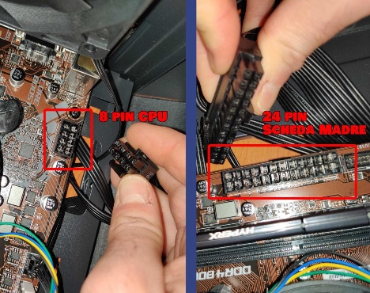
Step 7: Reconnect all cables
Connect the 24-pin motherboard power, CPU power, GPU power (if required), storage cables, case fans, and front-panel connectors.
Why now? All components need their correct power and data connections before testing.
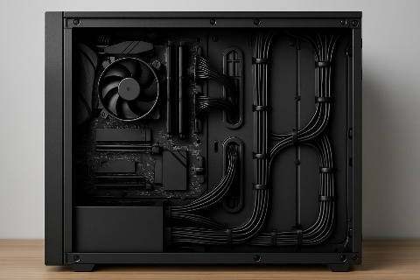
Step 8: Inspect connections and close the case
Check that components are secure, cables are clear of fan blades, and no tools or loose screws remain inside. Refit the side panel.
Why now? A final inspection helps prevent loose connections, short circuits, and airflow problems.
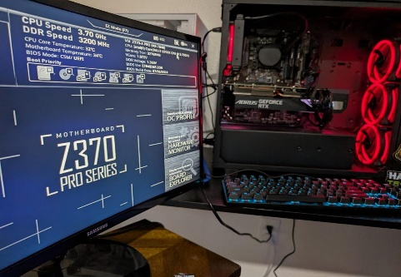
Step 9: Power on and test
Reconnect external devices and the power cable, switch on the PC, and verify that it starts successfully. Check that RAM and storage are detected and fans operate normally.
Why last? Testing confirms the reassembled components and connections are working correctly.
Q4. Create a checklist of safety precautions and tools needed before starting the PC assembly/disassembly process, and explain why each is important.
Ans.
Before beginning the assembly or disassembly of a desktop PC, taking proper safety precautions and gathering the right tools prevents physical injury to yourself and protects delicate electronic components from permanent damage.
1. Safety Precautions Checklist
- Unplug the Main Power Cord
  - Why it’s important: Always switch off the Power Supply Unit (PSU) and disconnect the main power cable from the wall outlet. Leaving a PC plugged in keeps standby power running through parts of the motherboard, creating a risk of electric shock or short-circuiting components if a tool or metallic object drops on them.
- Ground Yourself Against Electrostatic Discharge (ESD)
  - Why it’s important: Static electricity built up on your body can jump to sensitive microchips (like the CPU, RAM, or motherboard circuits) and destroy them without any visible spark. Touch a metal part of the PC case while plugged out, or use an anti-static wrist strap connected to an unpainted metal surface to safely discharge static electricity.
- Work on a Hard, Non-Conductive Surface
  - Why it’s important: Assemble or disassemble your system on a clean wooden, plastic, or laminate table. Avoid working on carpets, rugs, or beds, as soft fabrics generate high static electricity and can trap loose screws or tiny components.
- Clear the Workspace & Ensure Good Lighting
  - Why it’s important: A well-lit, clutter-free area ensures you can see fine details—such as small front-panel pins, screw threads, and socket alignment notches—preventing bent pins or dropped hardware.
- Handle Components by Their Edges
  - Why it’s important: Avoid touching golden contact pins, printed circuit board (PCB) traces, or the underside of the CPU directly. Oils and moisture from your fingers can corrode contacts, while direct touch increases ESD risks.
- Disconnect Power and Wait Before Touching Internal Parts
  - Why it’s important: Capacitors in the power supply and motherboard hold electrical charges for a short duration after unplugging. Wait a few moments after turning off the power switch to allow remaining energy to drain completely.
2. Essential Tools Checklist
- Magnetic Phillips Head Screwdriver (#2 Driver)
  - Why it’s important: The vast majority of PC screws (case panels, motherboard standoffs, power supply, expansion slots, and drive bays) use a standard #2 Phillips head. A magnetic tip holds screws in place, preventing them from falling into tight spaces inside the chassis where they could cause short circuits.
- Anti-Static Wrist Strap (ESD Strap)
  - Why it’s important: It safely grounds you continuously while working, neutralizing static build-up before it can harm sensitive silicon components.
- Thermal Paste (Thermal Interface Material / TIM) & Isopropyl Alcohol (90%+ Concentration)
  - Why it’s important: High-percentage isopropyl alcohol, combined with a lint-free microfiber cloth, cleans off old, dried thermal compound from the CPU and cooler base without leaving residue or causing corrosion. Fresh thermal paste fills microscopic air gaps between the CPU surface and heatsink to ensure optimal heat dissipation.
- Cable Ties, Velcro Straps, or Snips
  - Why it’s important: Keeping cables bundled and secured out of fan path channels improves internal airflow, keeps temperatures low, and prevents loose wires from snagging fan blades.
- Small Parts Tray or Magnetic Screw Bowl
  - Why it’s important: Computer assembly involves multiple types of small screws (motherboard screws, drive screws, PCIe bracket screws). Keeping them organized prevents loss and ensures you use the correct screw thread for each component.
- Flashlight or Headlamp
  - Why it’s important: Illuminates dark corners of the PC case, making it easier to read small labels on motherboard headers, inspect socket pins, and route cables cleanly.

